MALLA REDDY ENGINEERING COLLEGE (AUTONOMOUS)
II Year B.Tech II –Sem – COMPUTER AIDED DRAFTING OF BUILDINGS

1. Introduction to computer aided drafting software
2. Drawing of Single storeyed buildings plans of using CAD
3. Drawing of Multi storeyed buildings plans of using CAD
4. Developing sections and elevations for Single storyed buildings
5. Developing sections and elevations for Multi storyed buildings
6. Detailing of building components like Doors using CAD software‘s
7. Detailing of building components like Windows using CAD software‘s
8. Detailing of building components like Roof Trusses etc. using CAD software‘s
Course outcome / Course Objectives: After completion of the course

1. The students will be able to draft the plan, elevation and sectional views of the buildings, Industrial structures, and framed buildings.
2. The students will be able to analyze and design the simple structural members using computer software’s

Exercise 1: Introduction to computer aided drafting ( CAD)

Introduction

Computer Aided Drafting can be done by using the graphic commands available in High Level languages(HLL) like BASIC, FORTRAN, PASCAL, C and C++ .

CAD is an important industrial art extensively used in many applications, including automotive, ship building, and aerospace industries, industrial and architectural design, prosthetics, jewellery designing and many more. CAD is also widely used to produce computer animation for special effects in movies, advertising and technical manuals, often called Digital content creation (DCC )

Advantages of using CAD:
  - Increases effiency of your drawings
  - Time saving
  - Accurate, precise, & immediately alterable

Disadvantages of using CAD:
  - Financially costs more per license
  - Must and should have computer basic knowledge irrespective of concept

CAD is divided in many types
  - 2D
  - 3D
  - Orthographic
  - Isometric
  - Perspective

Exercise 2 : Software for CAD – Introduction to different software‘s

AutoCAD is a software application for 2D and 3D computer-aided design (CAD) and drafting
available since 1982 delvoped by Autodesk founded by John Walker.
Logos of the AUTODESK & AutoCAD® are trade mark registered the diamond like A shape
icon shows latest logo of AutoCAD for upcoming 2014 product

Official Name | Version | Release | Date of release | Comments
AutoCAD Version 1.0 | 1.0 | 1 | 1982, December | DWG R1.0 file format introduced.
AutoCAD Version 1.2 | 1.2 | 2 | 1983, April | DWG R1.2 file format introduced.
AutoCAD Version 1.3 | 1.3 | 3 | 1983, August | DWG R1.3 file format introduced.
AutoCAD Version 1.4 | 1.4 | 4 | 1983, October | DWG R1.4 file format introduced.
AutoCAD Version 2.0 | 2.0 | 5 | 1984, October | DWG R2.05 file format introduced.

AutoCAD Version 2.1 | 2.1 | 6 | 1985, May | DWG R2.1 file format introduced.
AutoCAD Version 2.5 | 2.5 | 7 | 1986, June | DWG R2.5 file format introduced.
AutoCAD Version 2.6 | 2.6 | 8 | 1987, April | DWG R2.6 file format introduced. Last version to run without a math co-processor.
AutoCAD Release 9 | 9.0 | 9 | 1987, September | DWG R9 file format introduced.
AutoCAD Release 10 | 10.0 | 10 | 1988, October | DWG R10 file format introduced.
AutoCAD Release 11 | 11.0 | 11 | 1990, October | DWG R11 file format introduced.
AutoCAD Release 12 | 12.0 | 12 | 1992, June | DWG R11/R12 file format introduced. Last release for Apple Macintosh til 2010.
AutoCAD Release 13 | 13.0 | 13 | 1994, November | DWG R13 file format introduced. Last release for Unix, MS-DOS and Windows 3.11.
AutoCAD Release 14 | 14.0 | 14 | 1997, February | DWG R14 file format introduced.
AutoCAD 2000 | 15.0 | 15 | 1999, March | DWG 2000 file format introduced.
AutoCAD 2000i | 15.1 | 16 | 2000, July
AutoCAD 2002 | 15.6 | 17 | 2001, June
AutoCAD 2004 | 16.0 | 18 | 2003, March | DWG 2004 file format introduced.

AutoCAD 2005 | 16.1 | 19 | 2004, March
AutoCAD 2006 | 16.2 | 20 | 2005, March | Dynamic Block introduced.
AutoCAD 2007 | 17.0 | 21 | 2006, March | DWG 2007 file format introduced.
AutoCAD 2008 | 17.1 | 22 | 2007, March | Annotative Objects introduced. AutoCAD 2008 and higher (including AutoCAD LT) can directly import and underlay DGN V8 files.
AutoCAD 2009 | 17.2 | 23 | 2008, March | Revisions to the user interface including the option of a Microsoft Office 2007-like tabbed ribbon.
AutoCAD 2010 | 18.0 | 24 | 2009, March 24 | DWG 2010 file format introduced. Parametrics introduced. Mesh 3D solid modeling introduced. Both 32-bit and 64-bit versions of AutoCAD 2010 and AutoCAD LT 2010 are compatible with and supported under Microsoft Windows 7.
AutoCAD 2011 | 18.1 | 25 | 2010, March 25 | Surface Modeling, Surface Analysis and Object Transparency introduced. October 15,  2010 AutoCAD 2011 for Mac was released. Are compatible with and supported under Microsoft Windows 7
AutoCAD 2012 | 18.2 | 26 | 2011, March 22 | Associative Array, Model Documentation. Support for complex linetypes in DGN files is improved in AutoCAD 2012. DGN editing.
AutoCAD 2013 | 19.0 | 27 | 2012, March 27 | DWG 2013 file format introduced.

AutoCAD 2014 | 19.1 | 28 | 2013, March 26 | File Tabs, Design Feed, Reality Capture, Autodesk Live Maps

Table showing various versions of AutoCAD since 1982

Top 10 free open source software as alternatives for AutoCAD :
- QCAD
This is an application that will allow you to draft two dimensions objects. It’s a great tool for all types of technical drawings, works for Windows, Mac OS X and many Linux and Unix Systems, and of course, it is completely free.

Creo Elements
One of the more popular choices for 3D work. It is a very fast and flexible alternative to AutoCAD with many options included that AutoCAD is known for having.

Google SketchUp
Just as Google seems to have an alternative for just about any paid program you can think of, it has an AutoCAD alternative as well. SketchUp has been lauded as a very versatile and easy-to- use alternative for design students and professionals.

FreeCAD
This is an Open Source 3D modeler that works great for mechanical engineering and product design. The program can help in various types of design and modeling programs and runs exactly the same way on Windows, Mac OSX and Linux platforms.

DraftSight
Great software for students, professionals and teachers which can be used to create, edit and view all types of DWG files, which is the most common format for most CAD-related applications.

BRL-CAD
A cross-platform and open source solid modeling system that has a bunch of different features to offer, including interactive geometry editing, image and signal-processing tools and large libraries for making tons of different types of geometric representations.

gCAD3D

This free software offers many features, including an integrated 3D-OpenGL viewer, a program interpreter for geometry and NC commands in 3D, an integrated NC processor and can be used with Windows and Linux. The website is a little sparse and confusing, but the freeware is not.

Archimedes
A 3D modeling application that allows you to create complex compound 3D shapes. It is touted for being one of the most functional free AutoCAD alternatives out there.

PythonCAD
One for the Linux users, this is a CAD package that was written in the Python programming language, hence the name. One of the best open-source CAD packages for Linux, and it’s also quite simple to use if you have any kind of prior experience with two and three dimensional modeling.

progeCAD
This one is free for private use but cannot be used commercially. It reads and writes pretty much all AutoCAD files and has an interface that is very similar to AutoCAD’s, which makes it highly recommended among people who have experience with AutoCAD beforehand.

DWG (DraWinG) is a binary file format used for storing two and three dimensional design data and metadata. It is the native format for several CAD packages including DraftSight, AutoCAD, IntelliCAD (and its variants)

We use commands in user interface of AutoCAD.
  - Commands are case Insensitive
  - Command means which had predefined function .

Viva Questions:
- Who is the father of AutoCAD?
- What is the difference between 2D and 3D?
- What are paid licensed softwares other than AutoCAD?

Exercise 3: Practice exercises on CAD software
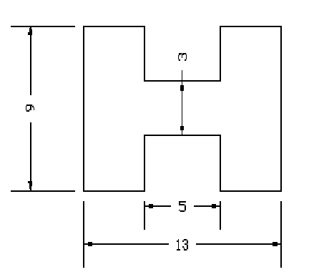
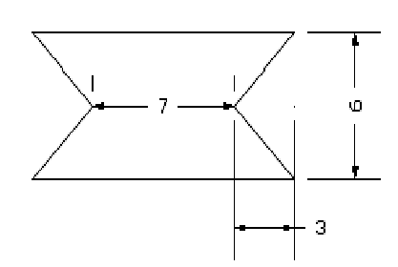

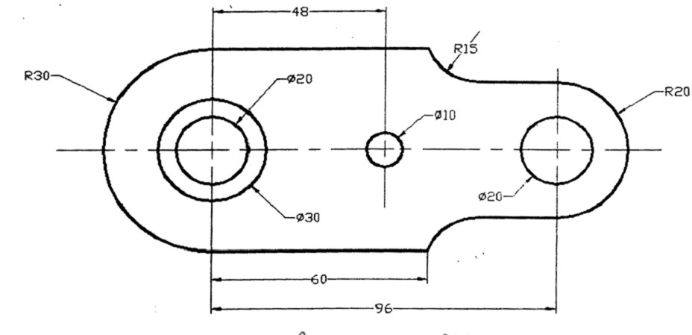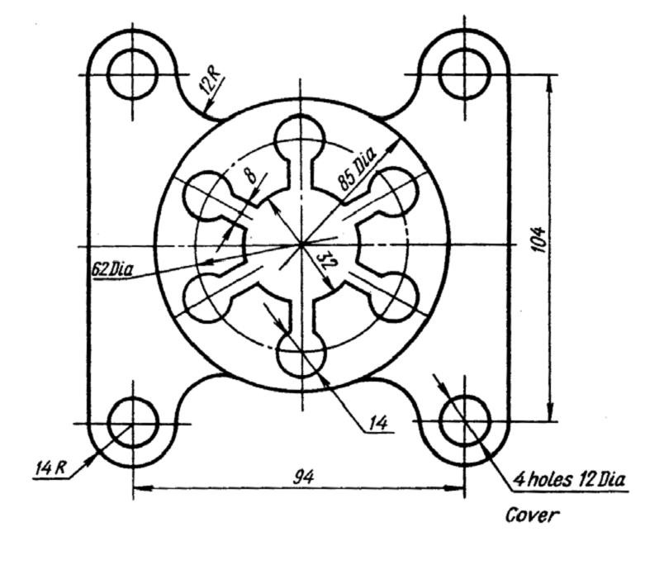

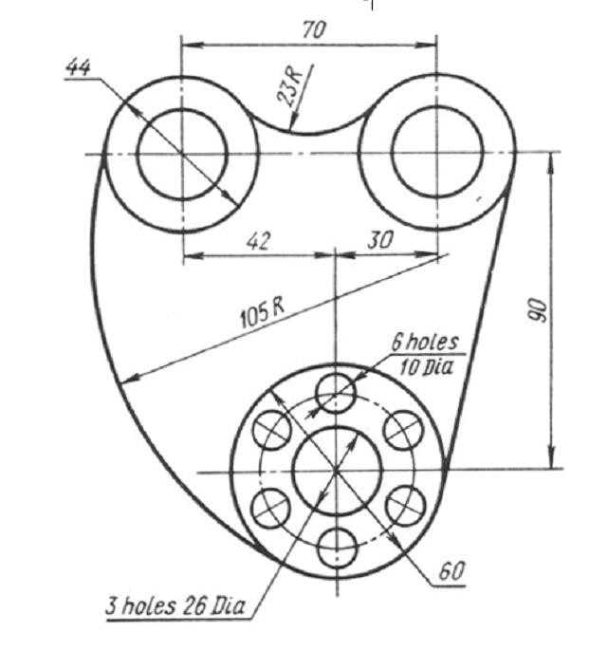

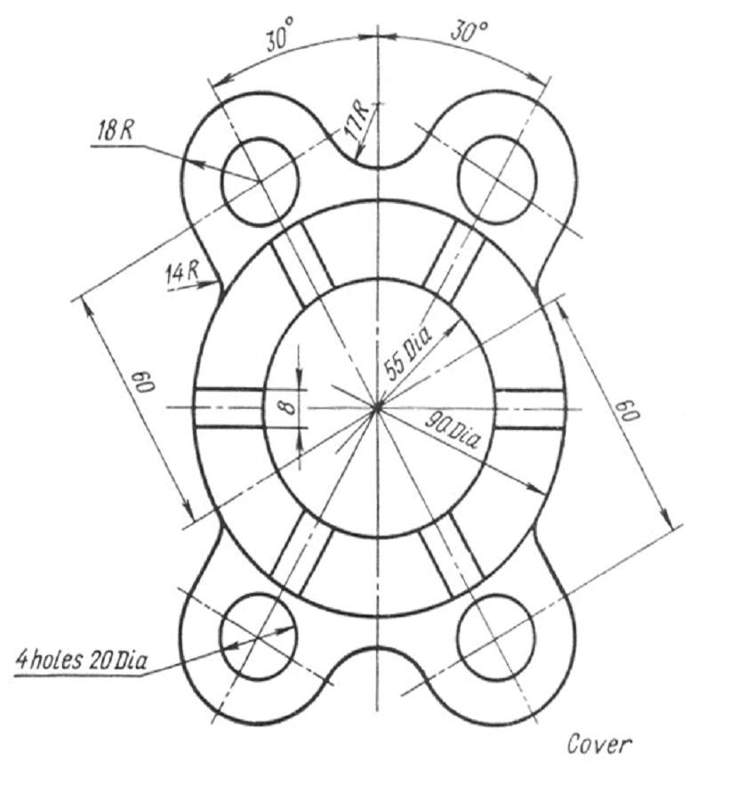

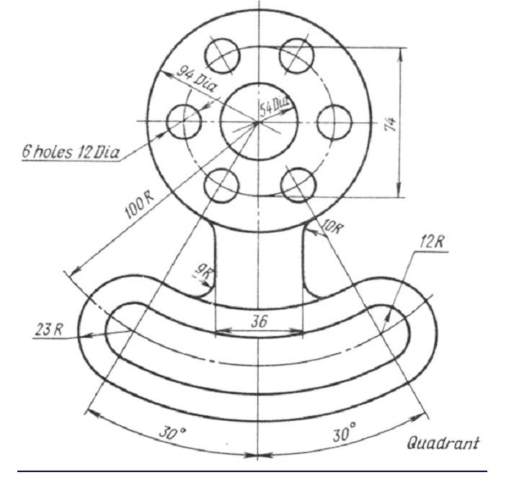

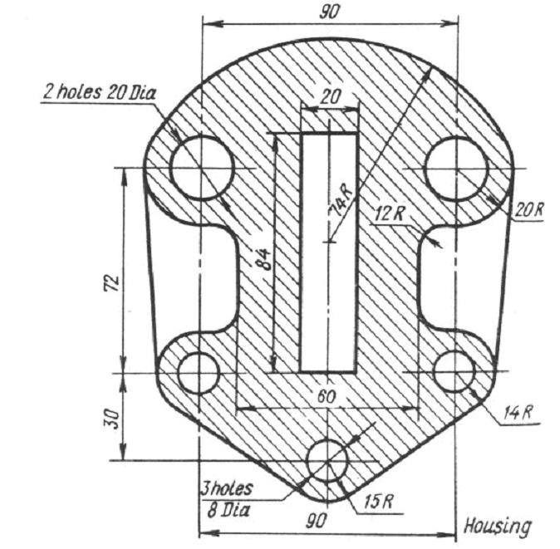

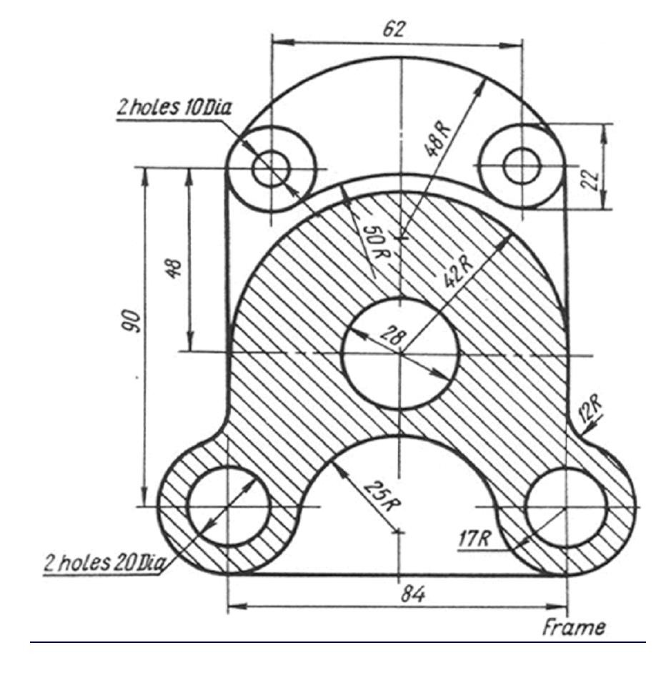

Command | Description | Options
ARC  or A | Draws an arc. The default method of drawing arcs is selecting three points (so-called "3 point arc"), which are the two endpoints of the arc and some other point along its locus. Other methods of drawing an arc can be specified by three letters, such as SEA, which means "Start Point, End Point, and Included Angle." | A Included angle  C Center point of arc  D Direction angle of a line tangent to the arc  E Endpoint of arc  L Length of chord passing thru both endpoints of the arc  R Radius  S Start point of arc  <RET> uses the end of the last line or arc as the start point for the arc
BREAK | Erases part of a line, arc or circle, or splits it into two lines or arcs | F allows respecification of first point
CHAMFER | Creates a chamfer (a angled line connection) at the intersection of two lines | D Sets chamfer distances  P Chamfers an entire polyline
CIRCLE  or C | Draws a circle of any size. The default method is to pick a center point and pick a point on the radius or type the radius dimension, but other methods can be selected. | 2P Specifies circle by picking 2 points on the diameter  3P Specifies circle by picking 3 points through which the circle will pass  D Allows entering the diameter dimension instead of radius dimension  TTR Specifies circle by picking two lines, arcs or circles for the circle to be tangent to, and entering the dimension of the radius  <RET> Enters radius of circle (the default)

COPY  or CP | Draws a copy of selected objects using two methods -- "base point" method, or "displacement" method. | M Allows multiple copies to be made of an object
ELLIPSE | Draws ellipses | C Allows specification of Center point of ellipse rather than first axis endpoint  R Allows specification of eccentricity rotation rather than length of second axis  I Draws Isometric circle in current isoplane
EXTEND | Lengthens a line, arc, or polyline to meet a specified "boundary edge" | U Undoes effect of last Extend command
EXPLODE | Separates a block, dimension or hatch pattern into its constituent entities or makes a polyline into a series of straight lines. In the case of a block that is exploded, if it was originally drawn on the 0 layer, it returns to that layer, regardless of the layer it was inserted on, and it loses its referential connection to the original block. In the case of a dimension or hatch pattern that has been exploded, their parts go back to the 0 layer, and are assigned the logical color (BYBLOCK) regardless of the layer they were drawn on. In the case of an exploded polyline, it loses any width it may have had.
ERASE  or E | Erases selected entities from the drawing

FILLET | Constructs an arc of specified radius between two lines, arcs, circles, or will create arcs of the specified radius at the vertices of a polyline. Radius of the arc to be constructed may be set to 0, which will make a sharp corner | P Fillets an entire Polyline at the vertices  R Allows setting of the fillet radius. Default value is 0. Radius remains set until changed again
HATCH | Allows drawing of cross- hatching and pattern filling | <pattern-name> uses hatch pattern name from library file to fill designated area with a pseudo- block hatch entity -- can be reduced to individual lines and points by EXPLODEing it.  <*pattern-name> uses hatch pattern name from library file to fill designated area with individual lines and points, not a block  U "User-defined" hatch pattern drawn of parallel lines with a specified distance between, at a specified angle, and either single- hatching or double (cross)-hatching  ? Lists names of available hatch patterns  <pattern-name> or U can be followed by a comma and the following sub-commands:  I Ignores any boundaries inside the outermost boundary  N Normal style of selecting boundaries with alternating hatched and unhatched nested areas  O Hatches outermost boundary area only
LIMITS | Changes the imaginary boundaries of the drawing, and controls whether drawing can be made outside of the boundaries. If Limit-checking is ON, drawing cannot be done outside of limits. | can be transparent  <2 points> Sets lower-left and upper -right drawing limits ON Enables limit-checking OFF Disables limit-checking

LINE  or L | Draws straight lines | <RET> In reply to From Point: prompt, line begins at end of previous line or arc  C In reply to To point: prompt, closes the polygon back to first "From Point"  U In reply to To point: prompt, undoes last line segment
MEASURE | Places points (or, optionally, Blocks) at intervals along a selected line, polyline, arc or circle. The interval distance is given by the user. If points are used as the marker to be placed along the entity, they are not visible unless the Point type is set to type 3 with the PDMODE command. | B specifies that a defined Block is to be used as a marker instead of a point.
MIRROR | Reflects designated entities about a user-specified axis
MOVE  or M | Moves designated entities to another location
OFFSET | Creates a new line, polyline arc or circle parallel to the entity and at a specified distance from it. | <number> specifies offset distance T "Through" allows specification of a point through which the offset line, polyline, arc or circle is to pass
OSNAP | Enables points to be precisely located on reference points of existing objects. This is the so- called "Running Mode" of OSNAP, which sets selection method to run continuously until set to NON (none) or until overridden by selecting another "Interrupt Mode" OSNAP method from the cursor menu.  Combinations of OSNAP methods can be used by selecting | can be transparent  CEN CENter of arc or circle END closest ENDpoint of arc or line  INS INSertion point of Text or Block  INT INTersection of line, arc, or circle  MID MIDpoint of line, arc, rectangle side, or polygon side NEA NEArest point selected by aperture on line, polyline, arc, or

 | a series of options separated by commas. For instance, if you want ot always pick either endpoints or intersection points when locating endpoints of lines, you would issue the command as follows:  OSNAP <RET> END,INT  <RET> | Circle  NOD NODe (another name for a Point)  NON NONe -- used when a "Running OSNAP" is on to temporarily turn off OSNAP selection  PER PERpendicular point to line, arc or circle -- when used with an arc or circle it will draw a line to the surface of the arc or circle heading toward the center point QUA QUAdrant point of arc or circle (top, bottom, right or left side)  QUI QUIck mode -- this is a modifier to one of the other OSNAP options -- it will find the first point that meets the requirements, not necessarily the closest point to the aperture.  TAN TANgent point to arc or circle
PEDIT | Allows editing of polylines which are already drawn | C Closes an open polyline  D Decurves, or returns a Spline curve to its control frame or series of connected straight lines  E Edit vertices  F Fits curve to a polyline -- makes a series of straight lines into a curve which will pass through the vertices J Joins a line or arc or another polyline to an open polyline  L Toggles line type generation to be either a continuous pattern of dashes passing through the vertices, or a pattern which starts and ends at each vertex  O Opens a closed polyline  S Uses the polyline vertices as a frame for a Spline Curve -- type of Spline Curve is set by the Variable "Splinetype."

 |  | U Undoes one editing operation W Sets a uniform width for the Polyline
PLINE | Draws a 2D polyline, which are connected line or arc segments with user-determined width and taper | H sets the half-width of the polyline segments  U Undoes previous segment W sets the width of polyline segments  <RET> Exits the Pline command The following options are available only as long as you are drawing in Line mode:  A Switches to the Arc mode to allow integration of arcs into the polyline  C Closes the polyline with straight segment  L Segment length (continues previous segment)  The following options are available only as long as you are in the Arc mode:  A Included angle CE Center Point  CL Closes with arc segment D Starting direction  L Chord length, or switches to line mode  R Radius  S Second point of 3-point arc
PLOT | Plots a drawing to a plotting device, a printer, or to a "Plot File."
POINT | Draws single points. Appearance of the points is set by the Variable PDMODE
POLYGON | Draws regular polygons with a specified number of sides.  Polygons are Polyline entities. | E Specifies size and rotation of polygon by picking endpoints of one edge  C Circumscribes polygon around a

circle
I Inscribes polygon within a circle
PURGE | Removes unused Blocks, Text Styles, Layers, Linetypes, and Dimension Styles from current drawing | A Purges All unused named objects B Purges unused Blocks  D Purges unused Dimstyles LA Purges unused LAyers LT Purges unused Linetypes SH Purges unused Shape files ST Purges unused Text Styles
QSAVE | Saves the current drawing "Quickly" without requesting a filename (as long as file has already been given a name)
QTEXT | Controls display of text -- command stands for "QuickTEXT" | ON Lines of text displayed as rectangles  OFF Lines of text displayed as text
QUIT | Exits AutoCAD -- if the current drawing has not been Saveds in its current state, a dialogue box will appear asking if you want to Save the drawing, Discard the changes, or Cancel the Exit command
REGEN | Regenerates the current Viewport by recalculating the vector locations of all endpoints
ROTATE | Rotates existing objects parallel to the current UCS
SAVE | Requests a filename and saves the drawing
SAVEAS | Same as SAVE, but also renames the current drawing and keeps the new name current
SCALE | Alters the size of existing objects | R Resizes with respect to a reference size

STRETCH | Allows moving a portion of a drawing while retaining their connections to other parts of the drawing. You cannot stretch Blocks, Hatch patterns, or Text entities, however.
TEXT | Draws text characters of any size with selected styles | J Prompts for justification options S Lists or selects text style  A Aligns text between two points, with style- specified width factor, AutoCAD computes approximate height proportional to length of text line  C Centers text horizontally about a defined point  F Fits text between two points, with specified height, AutoCAD computes approximate width factor to fill the distance between the two points  M Centers text horizontally and vertically about a defined point  R Right-justifies text  BL Bottom Left justification BC Bottom Center justification BR Bottom Right justification ML Middle Left justification MC Middle Center justification MR Middle Right justification TL Top Left justification  TC Top Center justification TR Top Right justification
TRIM | Erases a portion of selected entities that cross a specified "cutting edge" | U Undoes last trim operation
U or undo | Reverses the effect of the previous command
UCS | Defines or modifies the current User Coordinate System | D ("Delete") Deletes one or more saved coordinate systems  E ("Entity") Sets a UCS with the same extrusion direction as that of the selected entity

O ("Origin") Shifts the origin of the current coordinate system
P ("Previous") Restores the Previous UCS R ("Restore") Restores a previously saved UCS
S ("Save") Saves the current UCS
V ("View") Establishes a new UCS whose Z- axis is parallel to the current viewing direction
W ("World") Sets the current UCS to the World Coordinate System
X Rotates the current UCS around the X-axis Y Rotates the current UCS around the Y-axis Z Rotates the current UCS around the Z-axis ZA Defines a UCS using an origin point and a point on the positive portion of the Z-axis 3 Defines a UCS using an origin point, a point on the positive portion of the X-axis, and a point on the positive Y-portion of the XY plane
? Lists specified saved coordinate systems
UCSICON | Controls visibility and placement of the User Coordinate System Icon, which graphically indicates the origin and orientation of the current UCS. The options normally affect only the current viewport. | A Changes settings of all active viewports N ("NoOrigin") Displays the UCSICON at  the lower-left corner of the viewport (i.e., not at the Origin)  OR ("ORigin") Displays the UCSICON at the origin of the current UCS, if possible (if the origin point is not within the current viewport, the location of the UCSICON defaults to the lower-left corner of the viewport)  OFF Turns the UCSICON off ON Turns the UCSICON on
UNDO | Reverses the effect of multiple commands, and provides control over the "Undo" facility | <number> Undoes the <number> of most recent commands in reverse order  A ("Auto") Controls treatment of menu items as UNDO "Groups"  B ("Back") Undoes back to previous UNDO "Mark"  C ("Control") Enables/disables the UNDO feature  E ("End") Terminates an UNDO Group (a

sequence to be treated as one command) G ("Group") Begins an UNDO Group (a sequence to be treated as one command)
M ("Mark") Places "marker" in UNDO file (for use with "Back")
Control Sub-Options
All Enables the full UNDO feature
None Disables U and UNDO entirely, and discards any previous UNDO information saved earlier in the editing session
One Limits U and UNDO to a single operation
UNITS | Selects coordinate and angle display formats and precision | can be transparent
ZOOM | Enlarges or reduces the display magnification of the drawing, without changing the actual size of the entities | can be transparent  <number> multiplier from original magnification  <number X> multiplier from current magnification  <number XP>multiplier of magnification relative to paper space -- used for plotting to get right plot scale in each viewport  A ("All") fills limits of drawing to screen  C ("Center") makes picked point the center of the screen  D ("Dynamic") makes an adjustible rectangular lens appear on the screen which is capable of being made smaller or larger and moved to different positions over the drawing and once set by the user, the drawing will quickly zoom to the location and magnification set for the lens. This sub- command is no longer useful because all computers have very fast zooms naturally now.  E ("Extents") makes the farthest edges of the actual visible drawing fill up the graphics screen  L ("Lower-Left") makes the point picked become shoved to the lower-left corner of the graphics screen  P ("Previous") zooms back to whatever the

last zoom, previous to the current zoom was -
- AutoCAD stores about 10 of these, so you can walk backward in zoom magnification 10 times
V ("Virtual Screen") makes the largest area available to the graphics card fill the graphics screen -- this varies with the quantity of graphics RAM that your graphics card has
W ("Window") asks you to pick the lower left corner and the upper right corner of a zoom window and then fits that window to the graphics screen
3DPOLY | Creates a 3D polyline | C Closes the polyline back to the first point U Undoes (deletes) the last segment entered  <RET> Exits 3DPOLY command

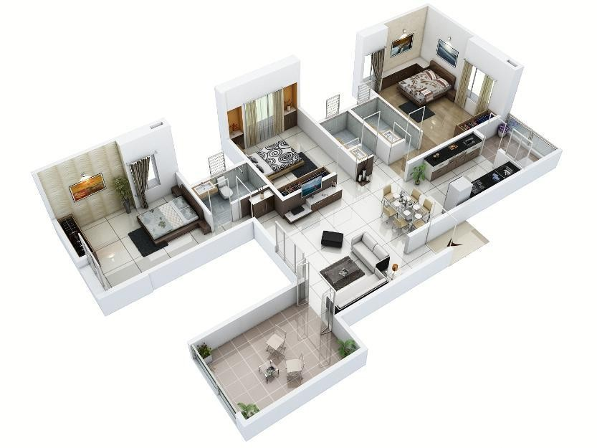

EXERCISE 4: Drawing of plans of buildings using software

- Single storeyed buildings b) multi storyed buildings

Building plan: a drawing that shows the shape, size, and arrangement of rooms in a building from above

The above picture a 3D isometric view of a building plan

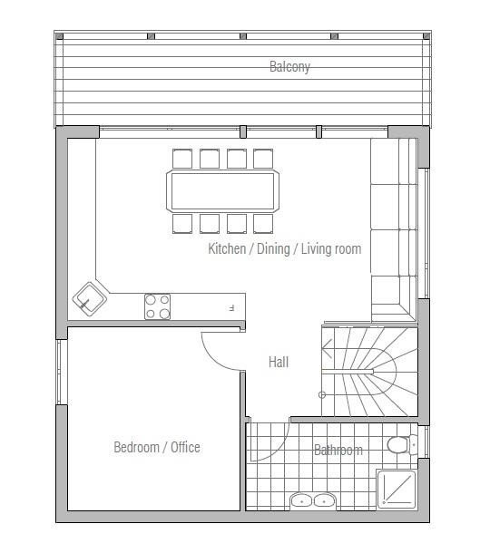
The above picture shows 2d Plan drawn in AutoCAD

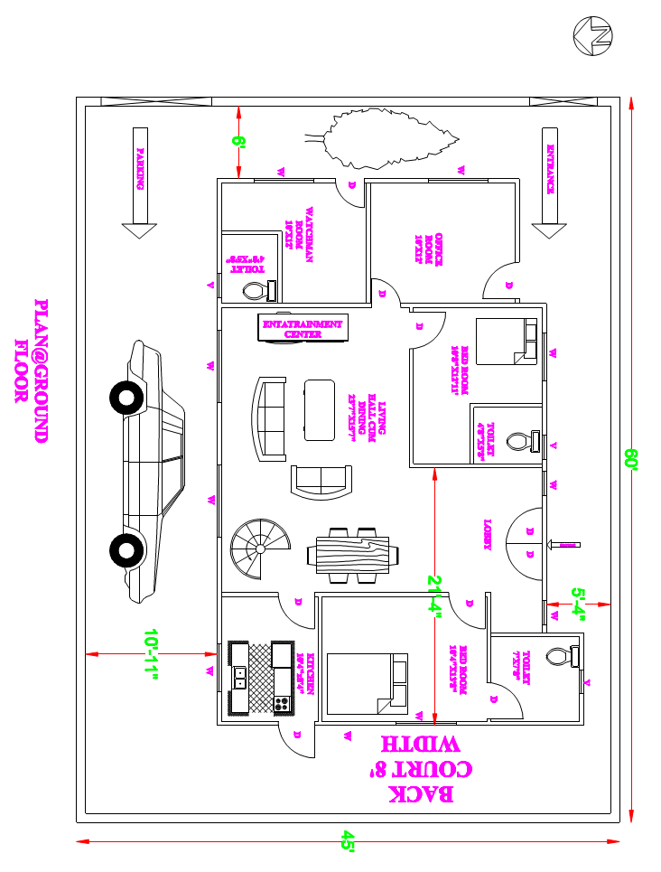

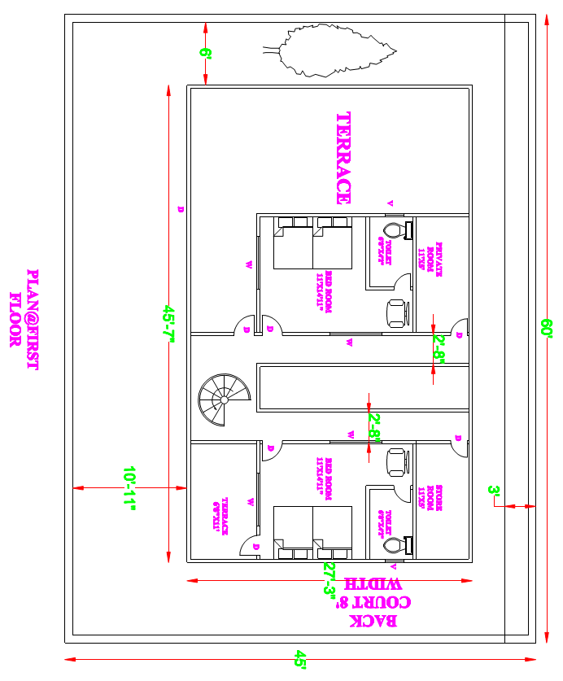

Exercise 6: Detailing of building components like Doors, Windows, Roof Trusses etc. using CAD software

Types of Doors:
- Battened and ledge door

- Battened and braced door

- Battened, ledge, and framed door

- Framed and paneled door

- Glazed door

- Flush door

- Louvered door

- Wire gauged door

- Revolving door

- Sliding door

- Swing door

- Collapsible steel door

- Rolling shutter door

- Mild steel sheet door

- Hollow metal door

- PVC door

Types of Windows :
- Fixed

- Pivoted

- Double hung

- Sliding

- Casement

- Sash

- Louvered

- Metal

- Bay

- Corner window

- Dormer window

- Gable window

- Lantern

